ARCHITECTURE

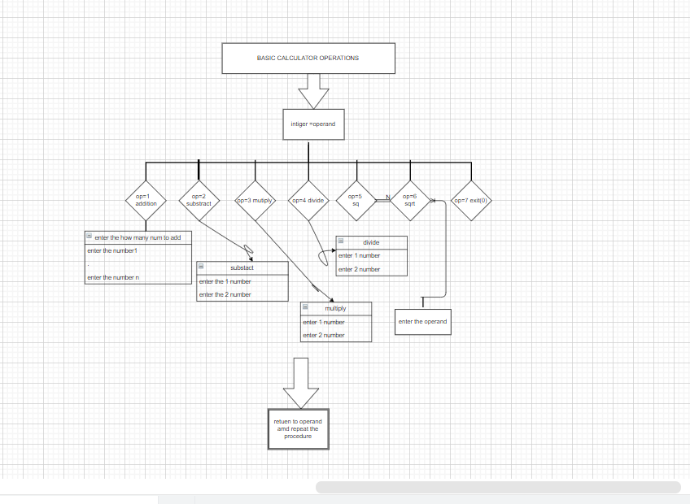

The above flowchart diagram shows the basic functioning of a calculator.

When the operand value is

Case 1: addition

Case 2: substract

Case3: multiply

Case 4:divide(if the second number is zero then we got error the number 2 is non zero value)

Case 5:square (finding the square of a number)

Case 6:square root

Case 7: exit(0)

The process continuously done.